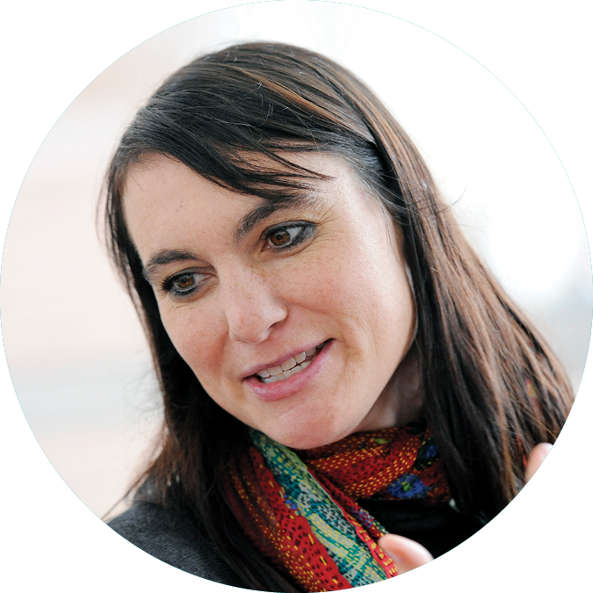

when to set up a donor-advised
fund

Is your situation similar to any of these?
- You make numerous charitable gifts throughout the year: A donor-advised fund provides a simple, flexible and economical way to manage your charitable contributions now and in the future.
- You have highly appreciated stock: You can avoid paying capital gains taxes on the gain in the stock and generate a tax deduction. Then, you can make gifts from your donor-advised fund over time.
- You have received an inheritance: You can create a memorial donor-advised fund in the name of your loved one and generate a tax deduction. Then you can make gifts, over time, to charities that were meaningful to you or your loved one.
- You are selling a house or vacation home: You can avoid paying capital gains taxes on the gain in the property and generate a tax deduction. Then, you can make gifts from your donor-advised fund over time. (You do not have to give the entire house to charity; you might only gift a small fraction of it.)
- You wish to memorialize a loved one: Create a donor-advised fund in the name of your loved one. Make periodic gifts to charities that were important to him or her.
- You wish to create a family culture of philanthropy: Introduce your children and grandchildren to philanthropy by setting up a donor-advised fund and letting the group decide which charities should receive gifts from the fund. Hold an annual board meeting and ask each person make a presentation to the group about a thoroughly researched charity and then vote.
- You are selling a business: If you have substantial capital gains from the sale of a business, you could avoid some capital gains taxes by contributing a portion of the proceeds to a donor-advised fund. You would generate a tax deduction that would further reduce your taxes. Make gifts to your favorite charities over time when you have more time to research them.
- You wish to create a corporate culture of philanthropy: Set up a donor-advised fund in the name of the company and generate an immediate tax deduction. Form a committee of employee volunteers to investigate and recommend gifts to charities. Build name recognition for good deeds. Help to create a healthy local economy, which will help your business to be successful.
- Use with a charitable remainder trust: Set up a donor-advised fund to be the remainder beneficiary of a charitable remainder trust. Specify your children as gift advisors to carry on your legacy of community involvement.

About Community First Foundation
Since 1975, Community First Foundation has helped individuals, families, businesses and nonprofits come together to improve the quality of life and create positive change in Jefferson County, the Denver metropolitan area and beyond.

Signature programs include ColoradoGives, Colorado Gives Day, Kids for ColoradoGives and The Innovators Society.
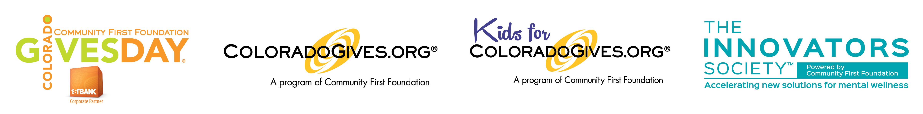

Our Mission
Community First Foundation increases generosity and powers community for positive change.

