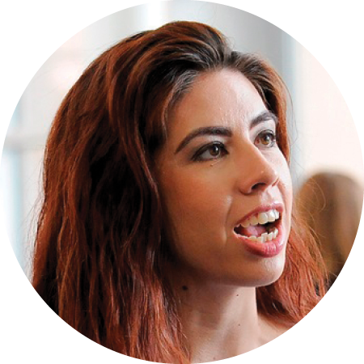
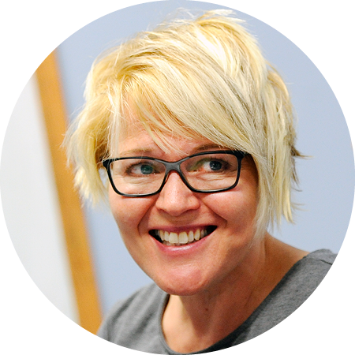
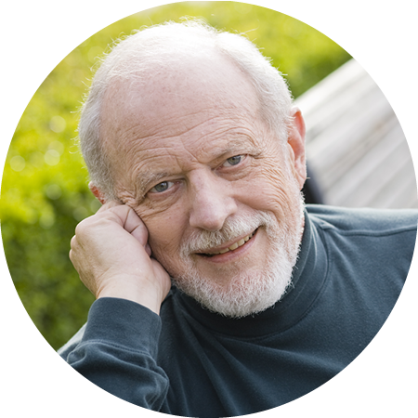
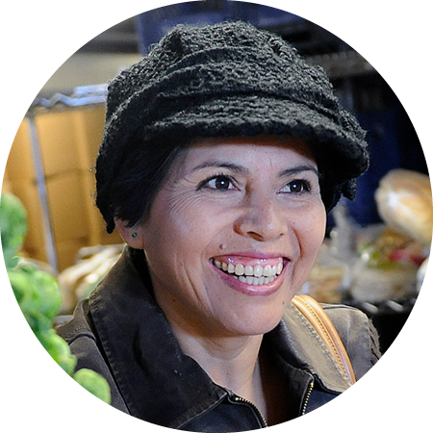
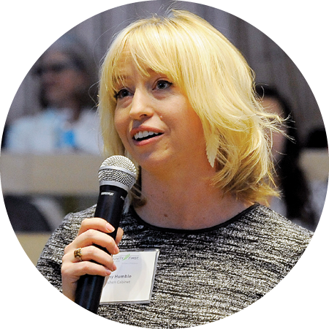
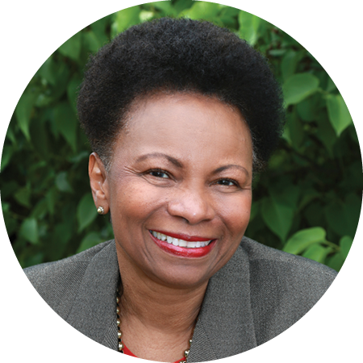

professional advisors council

Respected professionals partner with Community First Foundation
Community First Foundation is fortunate to partner with professional advisors to identify the best ways to guide their clients through the charitable gift process. We bring these top professionals together through a Professional Advisors Council. Members serve as a Foundation resource, offer insights into the changing work of philanthropic giving, learn more about the community and develop opportunities to address their clients’ philanthropic goals.
Esteemed Council Members
John Lischer, Chair
Ryley Carlock & Applewhite

Vera Divenyi
BNY Mellon Wealth Management

Kim Eilber
U.S. Trust
Heidi Gassman
Wade Ash Woods Hill & Farley, P.C.

Erin Hadary
Dunston Financial Group

Craig Jones
The Colony Group

Jeff Kadavy
Trail Ridge Wealth Management

Jason Lewis
Raymond James & Associates, Inc.

Julia McVey
Julia McVey, P.C.

Dan Morris
High Point Financial Group, LLC

Andy Pahl
Merrill Lynch
Charlie Rhoades
Pinnacle Wealth Management

Leslie Schaus
Strategem PC

A valued resource
Council members serve as ambassadors by increasing awareness of the Foundation’s work in the community. Members also broaden the circle of advisors who recommend the Foundation to their clients and help develop events and activities to support a strong connection between the professional advisor community and the Foundation.
Connecting donor vision with community needs
The Council gathers on a quarterly basis to present and discuss different topics surrounding charitable giving and estate planning. These events offer an opportunity for professional advisors to explore new strategies for meeting their clients’ charitable giving needs.
Meeting community needs
One of Community First Foundation’s strategic priorities is to power community by increasing generosity. The Professional Advisors Council is essential to achieving success in this area.
Charitable support and service
Community First Foundation supports professional advisors and their clients in every step of the charitable giving process. We help advisors:
- Identify their clients' charitable giving interests and motivations
- Match personal charitable interests with tax planning needs
- Facilitate gifts of cash and securities, as well as complex assets, including real estate, closely held stock and mineral interests
- Provide information on community needs, nonprofit organizations and programs that make a difference in the charitable areas their clients care about most
- Deliver grantmaking expertise

About Community First Foundation
Since 1975, Community First Foundation has helped individuals, families, businesses and nonprofits come together to improve the quality of life and create positive change in Jefferson County, the Denver metropolitan area and beyond.

Signature programs include ColoradoGives, Colorado Gives Day, Kids for ColoradoGives and The Innovators Society.
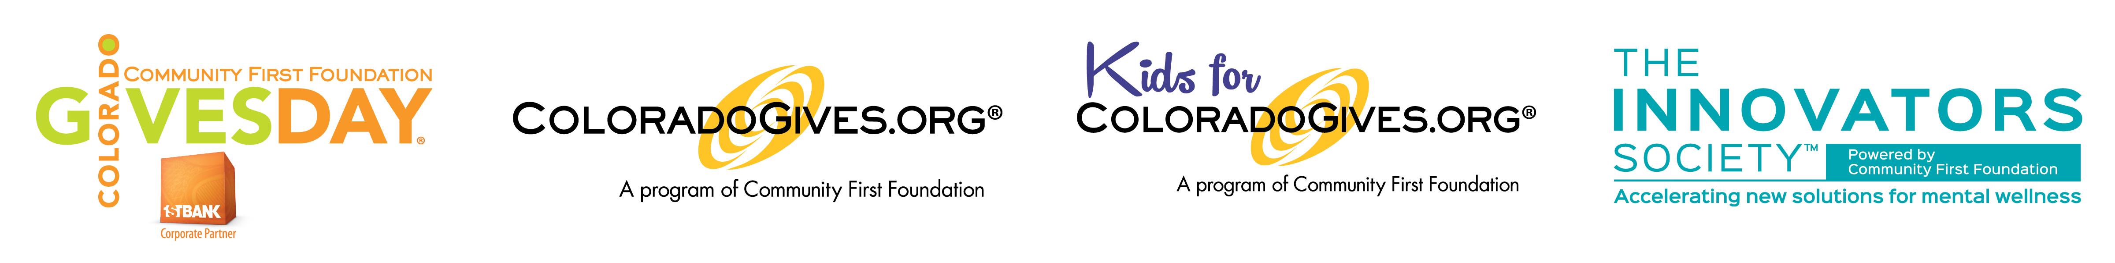

Our Mission
Community First Foundation increases generosity and powers community for positive change.
5.1.18

