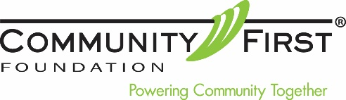

LETTER OF INTENT

<Date>

Community First Foundation
5855 Wadsworth Bypass, Unit A
Arvada, CO 80003

Dear Community First Foundation,

I am writing to inform you that I have requested a IRA Charitable Distribution from my Individual Retirement Account payable to Community First Foundation in the amount of <$Dollar Amount> from my plan/trustee administrator, <Name of Trustee/Administrator>.

Accordingly, upon receipt of payment from my trustee/administrator, please send me written acknowledgement that states the amount of my gift, that no goods or services were transferred to me by your organization in consideration for this gift and that my gift will not be placed in a donor-advised fund.

If you have any questions or need to contact me, my telephone number is <Phone Number> and my email address is <Email Address>. I have also included contact information for my plan administrator below:

Contact Name:
IRA Plan Administrator:
Telephone Number:
Email Address:

Sincerely,

<Signature>
<Donor Name>

