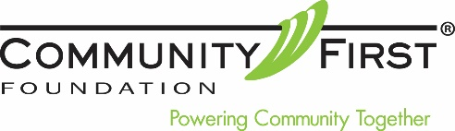

REQUEST LETTER TEMPLATE
Please use the sample letter below to request a distribution by check from your Individual Retirement Plan (IRA) administrator.

<Date>

<Name of Plan Provider>
<Address>
<City, State Zip Code>

RE: Request for IRA Charitable Distribution from Individual Retirement Account

Dear Sir or Madam:

Please accept this letter as authorization to make a charitable distribution from my Individual Retirement Account <Account Number>.

Please issue a check made payable to Community First Foundation (EIN 51-0157964) in the amount of <$ Dollar Amount>.

Please send this check to:
Community First Foundation
ATTN: Rebecca Olchawa Barker
Director of Philanthropic Services
5855 Wadsworth Bypass, Unit A
Arvada, CO 80003

In your transmittal letter to Community First Foundation, please list me as the donor, and my address of record, and copy me on the transmittal. It is my intention to have this transfer qualify during the 2018 tax year. Therefore, it is imperative that this distribution be received by Community First Foundation no later than November 20, 2018.

If you have any questions, I may be reached at <Phone>. Thank you for your prompt assistance.

Sincerely,

<Signature>
<Printed Name>

